VK audio player / Sound breaker 3.01   
Audio player connected to [vk.com](http://vk.com/). Features and capabilities: log in throw [vk.com](http://vk.com/), find and playback music based on artist or track name. (now it does not work due to VK API for music were closed)  
[https://github.com/TTMaestro/MusicPlayer](https://vk.com/away.php?to=https%3A%2F%2Fgithub.com%2FTTMaestro%2FMusicPlayer)

Creators: Kuzminov Sergey (general logic) Grigory Novikov (UI, Design)

class MainPageWindowsPhone: main class, with all logic

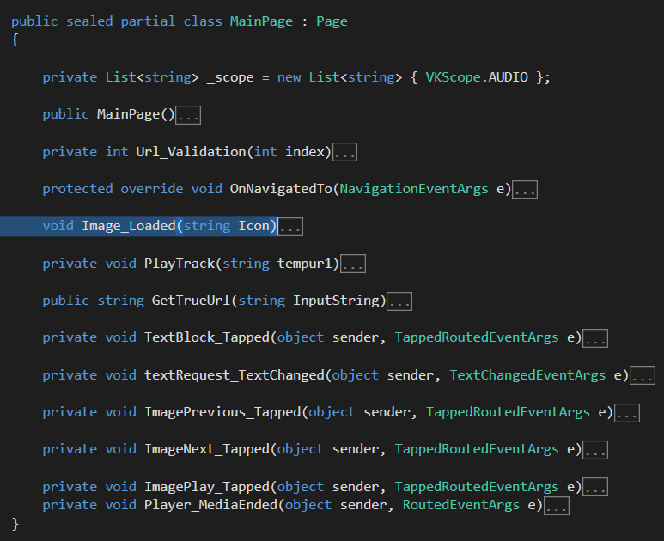

Class VKScope: class is used for authorization via VK

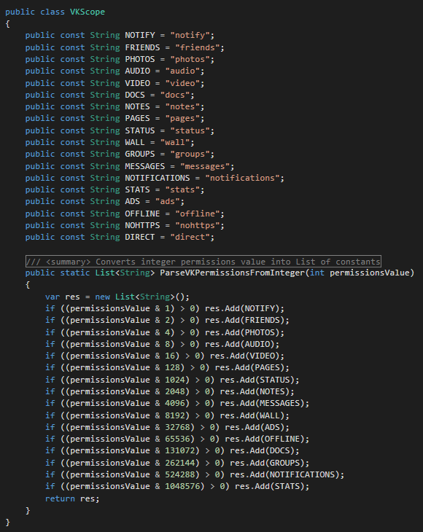

Class VKSDK is used for access to the app and for using whole library

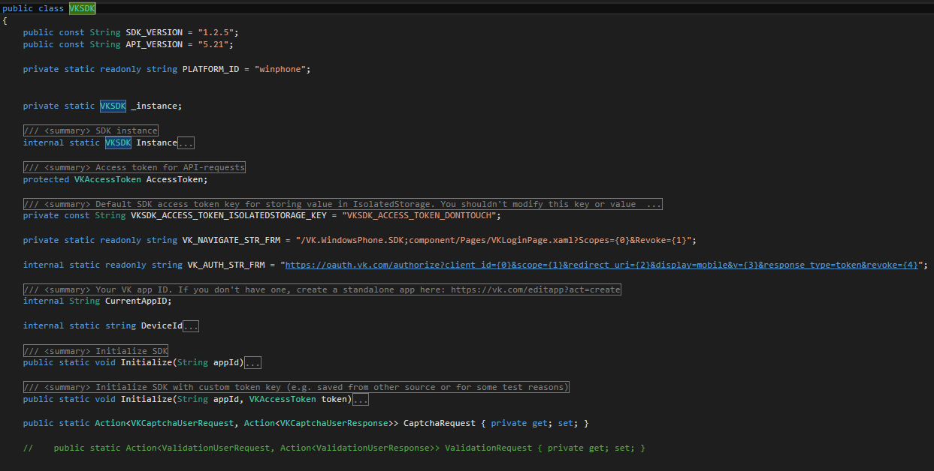

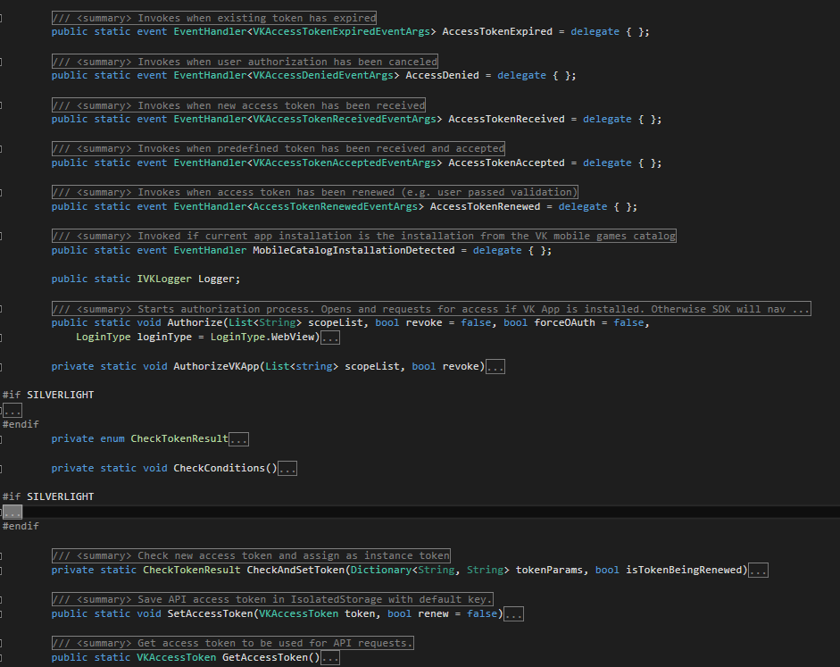

Class VKRequest is used for request to vk functions   
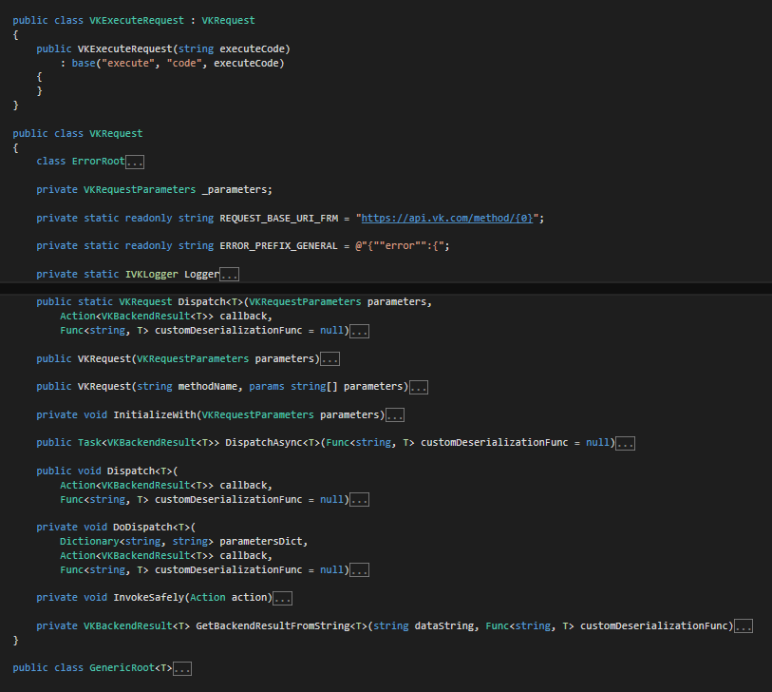

Сlass VKAudio is used for work with audio from vk 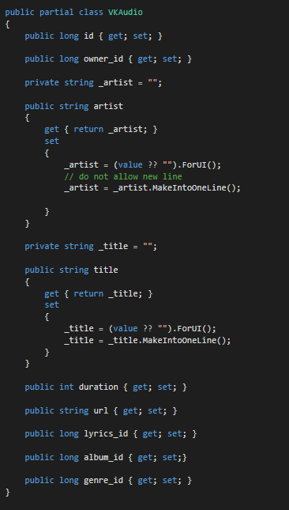

App´s interface

1) Rederict to authorize throw vk page, when open the app

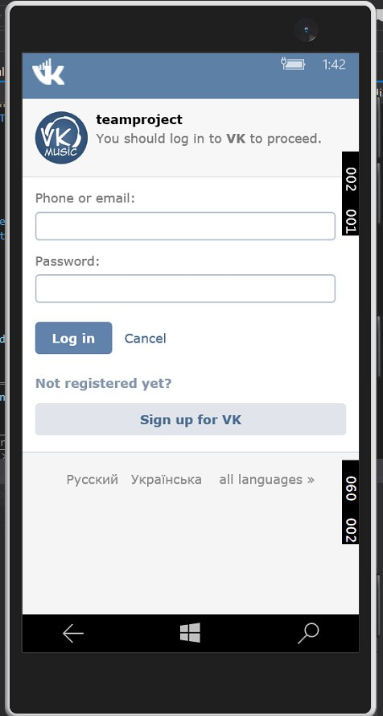

2) main page

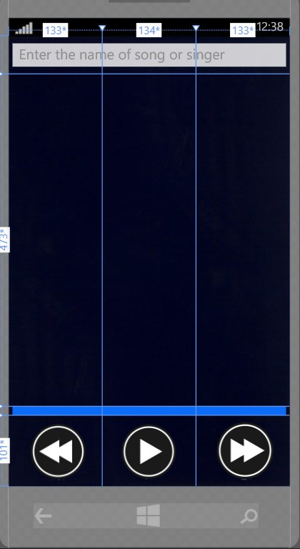

3) enter the song/artist and run the track(old design)

